3.1: a)
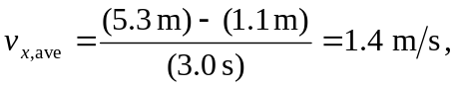
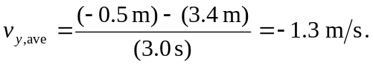

b) to two significant figures, 

